**Task 2: Deploy your ASP.Net Core application to Azure App Service.**

1. Via Visual Studio:
   1. Open your application in Visual Studio. Deploy the application to Azure App service using visual studio (choose F1 app service plan because it is free).
   2. Login to [Azure Portal](https://portal.azure.com/) and verify that all resources were created. Find your App Service and open the app link on the browser to verify it is up and running as expected.

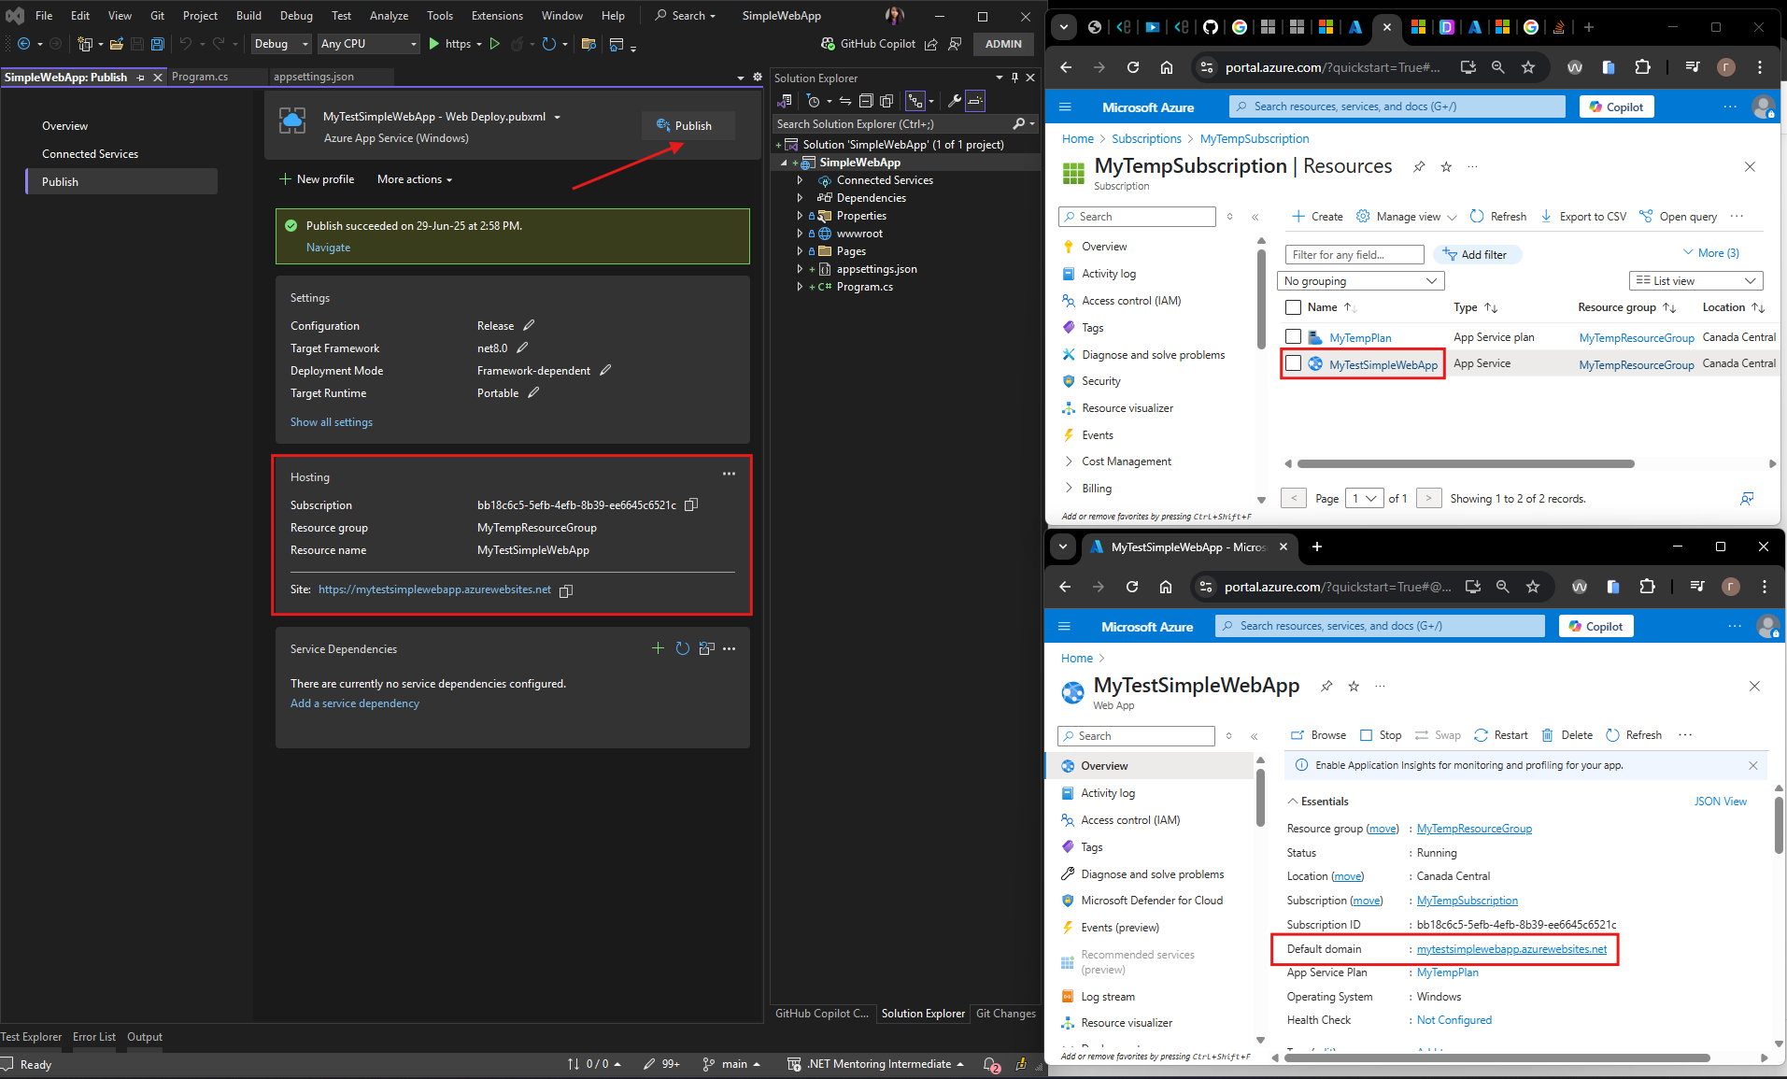

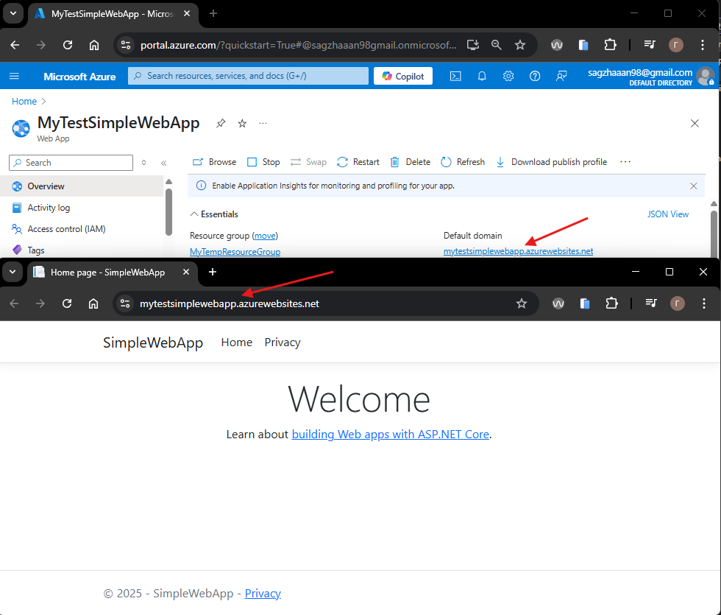

1. Via Azure CLI:
   1. Login into your azure account via Azure CLI.
   2. Create a new resource group.
   3. Create an azure webapp.
   4. Publish your app to a newly created azure webapp.
   5. Login to [Azure Portal](https://portal.azure.com/) and verify that all resources were created. Find your App Service and open the app link in the browser to verify it is up and running as expected.

1) Open a terminal or command prompt and ensure Azure CLI is installed. If Azure CLI is not installed, follow the instructions here: [Install Azure CLI](https://learn.microsoft.com/en-us/cli/azure/install-azure-cli).

2) Login to your Azure account via Azure CLI

>az --version

>az login

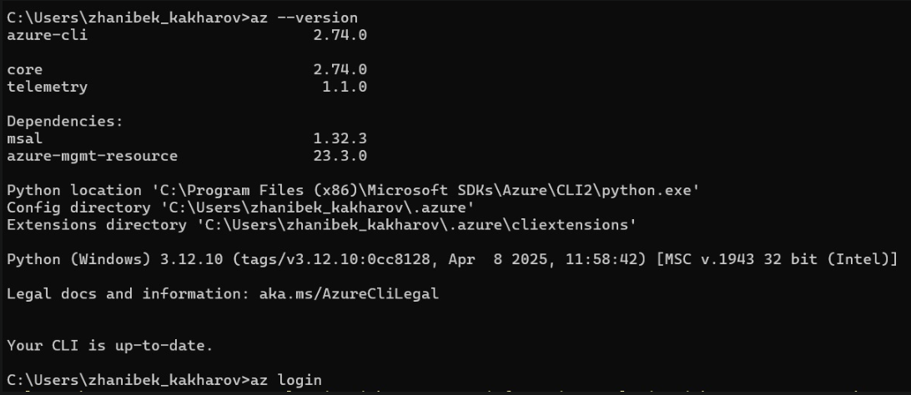

3) Created a new resource group

>az group create --name MySecondResourceGroup --location westus

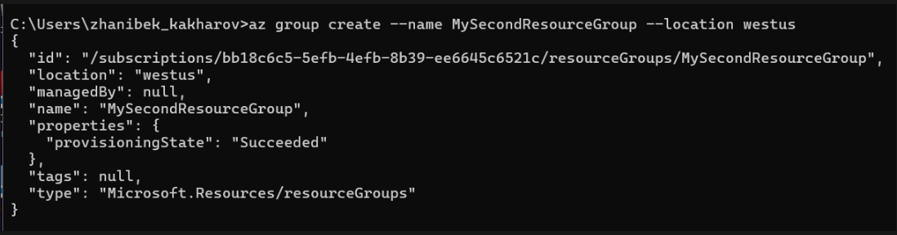

4) Created an Azure Web App

>az webapp create --resource-group MySecondResourceGroup --plan MyTempPlan --name MySecondTestWebApp0410

5) Created new WebApp named MySecondWebApp.

Published app to the newly created Azure Web App

>az webapp deploy --resource-group MySecondResourceGroup --name MySecondTestWebApp0410 --src-path C:\Users\zhanibek_kakharov\Desktop\MySecondWebApp.zip

In Azure:

6) Check that new AppService was created

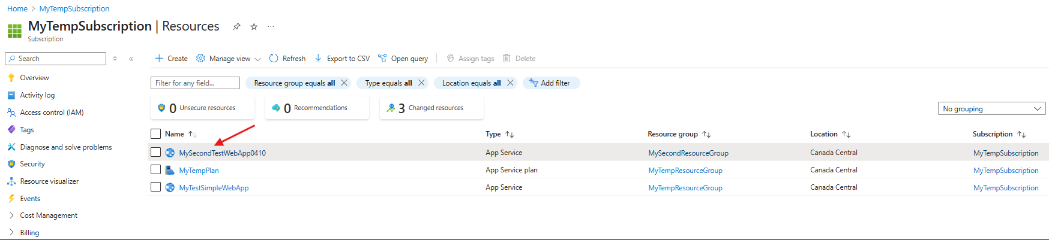

7) Check that app is running.



